🎮 GAME DESIGN DOCUMENT (GDD)
Faisal Al Asfoor 202304774
202300917 Ali Abdulla
202301152 Ali Alsaffar
201900576 Khizar Bakhsh
202200123 Habib Husain Alshoofa
202100747 Rawh Hasan
The Desert Winds

1. Overview
1.1 Game Title
Deserted Echoes
1.2 Concept
Deserted Echoes is a 2D pixel-art survival and exploration game set in a hostile desert environment. Players take on the role of LB, a survivor navigating extreme conditions while searching for his kidnapped friends.
The game blends:
- Survival mechanics
- Exploration
- Combat
Players must manage limited resources (water, food, equipment) while facing environmental hazards and enemies.

1.3 Design Goal
Create an immersive survival experience that challenges players to balance:
- Exploration
- Combat
- Resource management
1.4 Player Goal
- Survive the desert
- Progress through all levels
- Defeat enemies
- Rescue all kidnapped friends
1.5 Genre
2D Pixel Art Survival / Exploration / Action
1.6 Target Audience
- Age: 12+
- Casual to intermediate players
- Fans of survival, exploration, and resource management

1.7 Platform & Controls
Platform
PC
Controls
Keyboard
- W, A, S, D → Movement
- Shift → Sprint
- Space → Dodge
- E → Interact
- Tab → Inventory
- M → Map
- 1–4 → Item Slots
- ESC → Pause
Mouse
- Left Click → Attack
- Right Click → Secondary Action
- Mouse Movement → Aim

1.8 Unique Selling Points
- Dynamic Day/Night Survival System
- Harsh environmental mechanics (heat & cold)
- Pixel-art desert atmosphere
- Blend of survival, combat, and exploration
- Progressive difficulty scaling
- Strategic resource management

2. Narrative & Progression
2.1 Story Summary
Lucian Blaze is stranded in a vast desert after a bandit ambush. His friends have been kidnapped and scattered across regions controlled by desert raiders.

2.2 Progression Structure
- Early Game
  - Basic survival mechanics
  - Resource gathering
  - Introduction to enemies
- Mid Game
  - Increased difficulty
  - Environmental hazards
  - Mini-boss encounters
- Late Game
  - Rescue missions
  - Stronger enemies
  - Narrative development
- Final Stage
  - Final boss confrontation
  - Rescue all friends
  - Story resolution

3. Core Gameplay
3.1 Gameplay Loop
Players will continuously:
- Explore environments
- Gather resources
- Manage survival stats
- Engage in combat
- Progress through levels

3.2 Player Experience
- Early Game: Vulnerability, scarcity
- Mid Game: Strategy and planning
- Late Game: Mastery and intensity

3.3 Game Setting
A stylized desert world featuring:
- Sand dunes
- Ruins
- Bandit camps
- Hazard zones

3.4 Game Duration
- Total: 4–6 hours
- Per level: 15–25 minutes

4. Art & Audio
4.1 Visual Style
- 2D Pixel Art
- Warm desert palette (yellow, orange, brown)
- Dynamic lighting (especially at night)

4.2 Effects
- Storms
- Lighting-based visibility
- Environmental damage indicators

4.3 Camera
- Top-down perspective
- Smooth player tracking

4.4 Sound Design
- Combat effects
- Environmental sounds (wind)
- UI interaction sounds

4.5 Music
- Calm exploration tracks
- Intense combat tracks
- Dynamic transitions

5. Game World
5.1 Characters
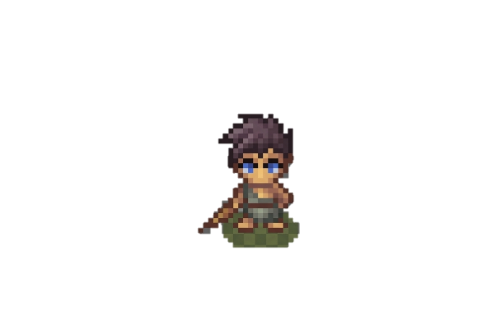
Protagonist
Lucian Blaze (LB)
- Determined survivor
- Main playable character
Enemies
A mixture of mobs and bosses that are going to have 3 versions for each different difficulty levels
- Easy
- Normal
- Hard
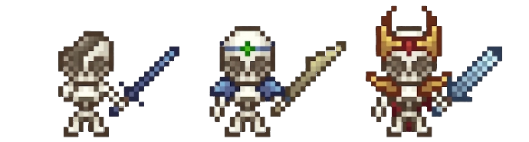
Mobs:
Skeletons: The skeleton warriors.

Easy: A Fragile broken skeleton wielding a cursed blade and strikes with deadly precision.
Strengths: Fast Attack Speed & High Accuracy
Normal: He will be outfitted with the remains of old guard armor carrying a bone blade that hard yet deadly.
Strengths: Increased defense from armor
Hard: The commander of the undead dressed in his golden blood cloak wielding a diamond sword (can be distinguished by the red & golden armor and horned helmet)
Strengths: High Critical Hit, Stronger defense from higher armor and health.
Location: Dungeons – Caves.

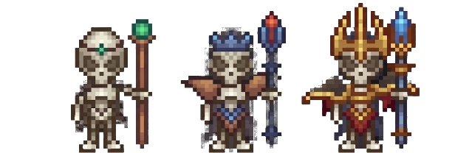
Lich’s: The sorcerer skeletons.

Easy: Outfitted in a leather robe wielding the green sorcerer’s staff, a staff of boundless magic.
Strengths: Fast Attack Speed & High Accuracy
Normal: Outfitted in his bronze armor wielding the fire staff, a staff that burns the souls of his enemies.
Strengths: Increased defense from armor
Hard: Outfitted in his Crimson Gold armor wielding the Ice staff, a staff of Immeasurable strength able to freeze his enemies within seconds (can be distinguished by the red & golden armor and horned crown).
Strengths: High Critical Hit, Stronger defense from higher armor and health and can slow players down
Location: Dungeons – Caves.

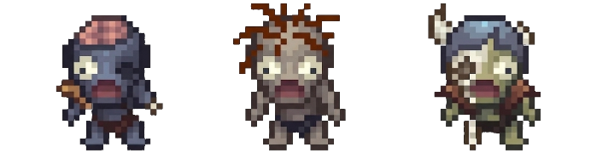
Zombies: The Undead wandering zombies.

Easy: A zombie with a missing eye and torn and worn rags, he roams the world with his rusty weapon that packs a punch.
Strengths: High durability (takes longer to kill) and strong melee hit
Normal: A Roaming zombie with both eyes and a head full of hair that lungs at everything he sees.
Strengths: Sprint/Lunge attacks and increased health
Hard: A roaming zombie wearing a torn hood and copper armor with a missing eye and deformed leg that spits acid that corrodes the enemies.
Strengths: High resistance to damage due to armor
Location: Dungeons – Caves – wilderness.

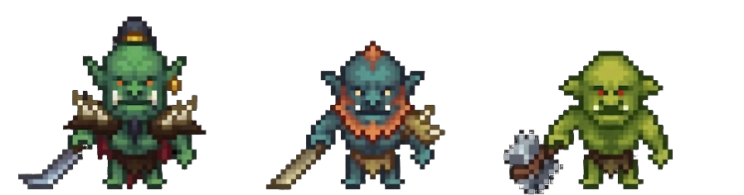
Orcs: The savage Orc Warriors.

Easy: A big soft slimy green Orc wielding a iron hammer that he swings with all his might and strength destroying everything in his path.
Strengths: Heavy Hits and knockback effect.
Normal: A big barbaric Orc with an oxidized copper color for his skin wielding a golden blade, that slices everything that gets in his way.
Strengths: Increased health and knockback effect.
Hard: A big brolic Orc with an emerald, green skin, outfitted in throned armor wielding a sharp metal sword that he swings with all his might.
Strengths: High damage hit and increased health due to armor as well as heavy attacks.
Location: Dungeons – Caves.

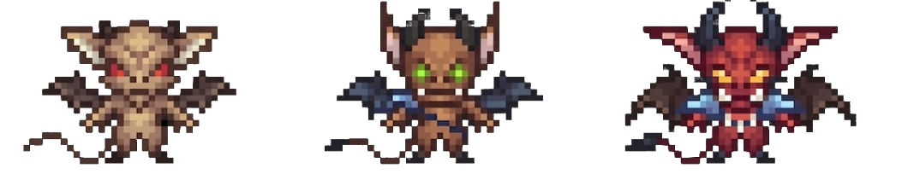
Imp’s: The fiery bats from the depths of hell.

Easy: A small wild imp with glowing red eyes that dive’s intruders and uses his sharp claws to claw at them.
Strengths: Sprint/Lunge attacks
Normal: The blue winged imp with glowing green eyes that dives intruders using his sharp horns as a missile and stings them with his tail.
Strengths: Increased health
Hard: The red Imp with glowing yellow eyes that dives intruders and shoots fireballs at them that he generates from inside of him.
Strengths: High damage hit and increased health due to armor as well as heavy attacks.
Location: Dungeons – Caves.

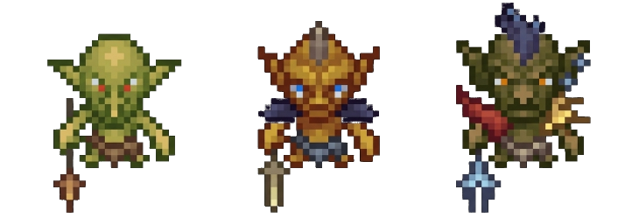
Goblins: The gremlins of the sands.

Easy: A young armature Goblin wielding a stone spear that targets any passerby.
Strengths: Quick Speed and can attack in groups.
Normal: A yellowish skinned Goblin wearing blue armor wielding a sword that he swings with might.
Strengths: Quick Speed and increased health due to armor.
Hard: A goblin with dark green alligator-like skin wielding a diamond bident that he lunges with it and uses it to strike unwanted travelers.
Strengths: Can quick chain attack.
Location: Dungeons – Caves – Wilderness.

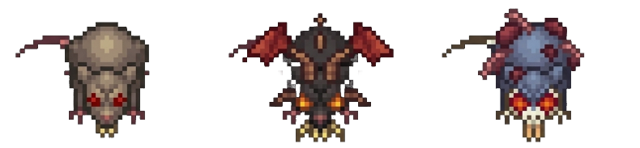
Rats: The giant desert rats.

Easy: A grayish Rat with red eyes that uses his sharp teeth to chomp down any passerby.
Strengths: Able to Swarm Players
Normal: A mutated rat that has spider-like fangs and bat wings, that spits venom as he hovers over any passerby.
Strengths: Poison/Venom Attack
Hard: A mutated zombie rat with glowing red eyes, that lunges at any passerby and tries to. infect them
Strengths: High Attack and speed
Location: Dungeons – Caves – Wilderness.

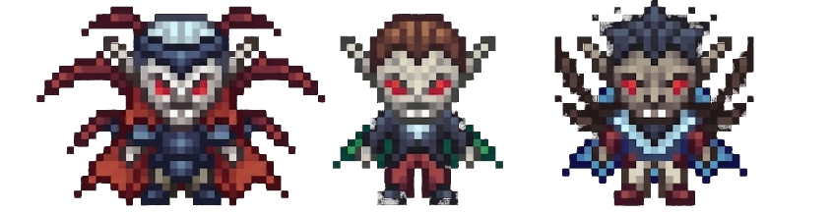
Bosses:
Vampires: Blood sucking bats.

Easy: A suit wearing Vampire that flies and dives to scratch and claw at unwanted visitors.
Strengths: Fast attack speed
Normal: A blue winged Vampire that uses his fangs to suck the blood out of his enemies.
Strengths: High agility (Fast movement speed)
Hard: A red winged Vampire that uses blood magic and flies and attacks his enemies.
Strengths: High speed High health due to armor and heavy attacks
Location: Dungeons – Caves
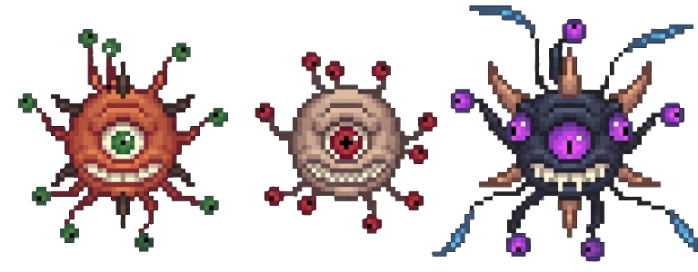

The Eye: A flying chaos machine.

Easy: A red-eyed baby Eye that flies and shoots laser beams at enemies.
Strengths: Consistent flight
Normal: A green-eyed orange Eye that lunges at enemies and uses its tentacles to attack them.
Strengths: Melee and ranged combo
Hard: A purple-eyed deep blue skinned eye that flies above his enemies and shoots fire balls at them to eliminate them.
Strengths: Multi attack and uses fire balls and extra health
Location: Dungeons – Caves.

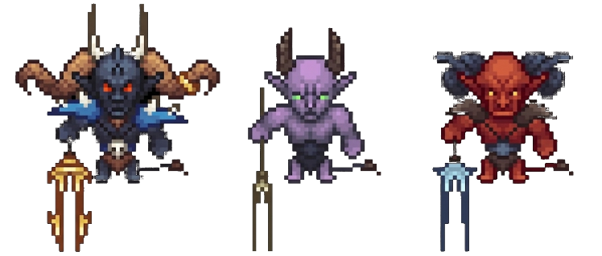
Demons: The hellspawn destroyers.

Easy: A purple skinned demon wielding a bident that he uses to attack enemies
Strengths: Strong melee attacks
Normal: A red-skinned demon from the depths of hell wielding a diamond bident that he uses to attack his enemies.
Strengths: Increased damage and small health buff
Strengths: Strong melee attacks
Hard: A deep, blue-skinned demon from the depths of hell welding the golden bident that he uses to attack his enemies as well.
Strengths: Heavy attack, extreme health
Location: Dungeons – Caves.

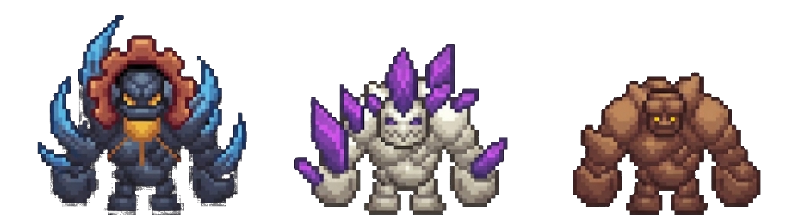
Golems: The elemental beings

Easy: A rock Golem that lunges at his enemies and punches them.
Strengths: Moderate durability (Health).
Normal: A quartz golem that lunges at enemies and punches them as well as throwing the amethyst shards at them too.
Strengths: Strong melee attacks and increased health.
Hard: A deep, blue-skinned golem that breathes fire and uses his hands to smash the ground creating a strong ripple that knocks back the enemies
Strengths: Heavy attacks and ground slam shockwave
Location: Dungeons – Caves
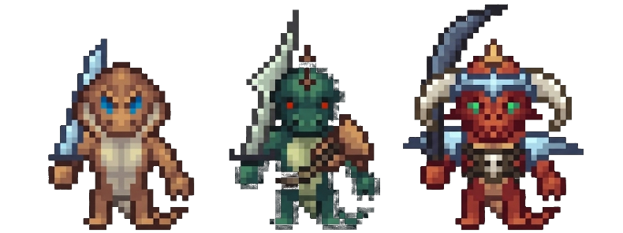
Lizards: Lizard… Lizard… Lizard…

Easy: A tan Lizard wielding an iron sword that attacks everyone.
Strengths: Fast melee attacks
Normal: A green Lizard wielding an iron sword that attacks everyone.
Strengths: Strong but slow melee attacks
Hard: A red Lizard wearing iron armor and a horned helmet, wielding a iron sword that attacks everyone and can spit fire.
Strengths: High health and armor.
Location: Dungeons – Caves

5.2 Environments
- Desert plains
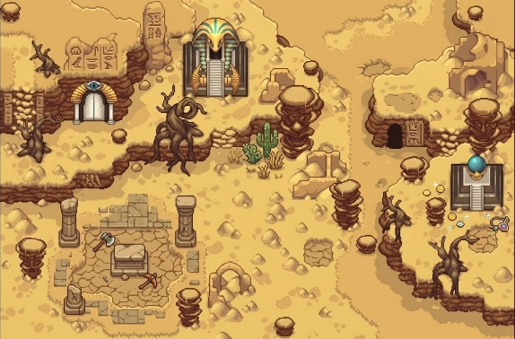
- Night survival zones
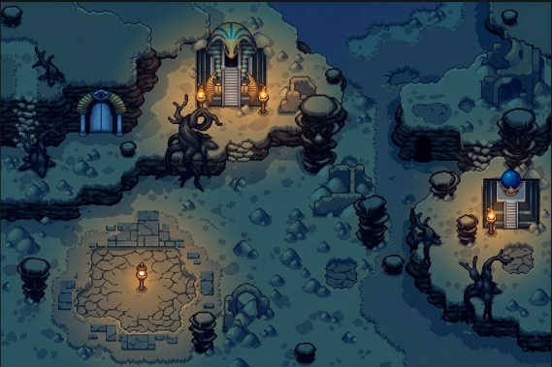
- Hazard areas
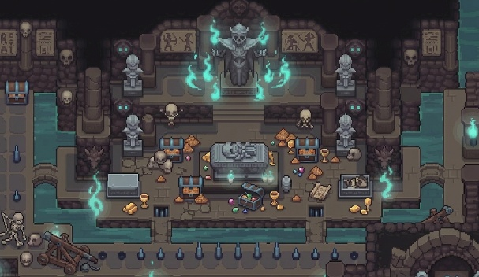

5.3 User Interface
- Main Menu
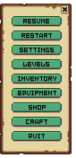
- Inventory Screen
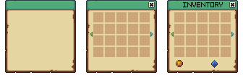
- HUD (health, stamina, temperature)

- Setting Menu
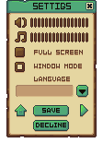
- Game Over / Victory Screens
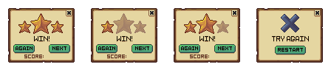

6. Level Design
6.1 Structure
- 12 Levels + Open World Hub
6.2 Level Composition
Each level includes:
- Exploration
- Combat encounters
- Resource management
- Objectives
- Exit or boss fight

7. Key Gameplay Moments
- First survival challenge
- First enemy encounter
- First night cycle
- First mini-boss
- First rescue mission
- Final boss battle
8. Systems & Features
8.1 Core Systems
- Movement System
- Combat System
- Survival System (health, temperature)
- Enemy AI
- UI System
- Level Progression

8.2 Custom Features
1. Dynamic Night Visibility System (Ali Abdulelah) (advance feature )
- Limited visibility
- Flashlight-based vision
2. Collectible & Equipment System (Khizar Azhar)
- Armor bonuses
- Resource collection
3. Teleport / Fast Travel System (Ali Alsaffar)
- Checkpoint-based travel
Detailed Description:
The game features an open-world hub composed of six tunnels. Each tunnel contains entrances that lead to two different levels (for example, Tunnel 1 connects to Level 1 and Level 2).

These entrances function as portal doors, acting as a teleportation system that transports the player directly to the selected level.

At the end of each level, there is also a return portal that brings the player back to the open-world hub.

Players can revisit previously completed levels to gather additional resources. Completed levels will be clearly marked with a *“Done” indicator*.
4. Difficulty System (Faisal Alasfoor)
- Easy / Medium / Hard scaling
5. Player Profile & Inventory (Habib)
- Stats tracking
- Progress management
6. Dynamic Weather System (Rawh)
- Storms
- Day/Night cycle
- Movement impact
7. UI / Settings / Saving System (Ali Abdulelah)
- Auto-save system (checkpoints, key events)
- Manual save/load functionality
- Settings menu (graphics, audio, controls)
- Save data management (profiles, progress tracking)

8.3 Lives System
Lives System
The Lives System determines how many times the player can die before restarting a level. This system adds tension, encourages careful decision-making, and scales with difficulty mode.
Base Rules
- Each level provides the player with a set number of lives.
- When the player’s HP reaches zero, they lose one life.
- Losing all lives results in a Level Restart from the beginning.
- Lives are fully restored when a level is completed.
Difficulty Scaling
- Easy: 5 Lives
- Normal: 3 Lives
- Hard: 1 Life
  - Optionally: Hard mode can activate Permadeath, where losing the single life restarts the entire game.
Checkpoints
- Checkpoints save progress within the level (items collected, enemies defeated).
- If the player dies but still has lives remaining, they respawn at the last unlocked checkpoint.
- If all lives are lost, the player returns to the start of the level, and checkpoints reset.
UI Integration
- A Lives Icon will appear on the HUD next to HP and Stamina.
- Displays remaining lives numerically or as heart/skull icons.
- On death, a “You Lost a Life” prompt appears with remaining count.
Design Goals
- Increase tension without creating frustration.
- Reward cautious exploration and resource management.
- Add replay value for higher difficulty levels.
- Allow players to learn from mistakes through checkpoint respawns.

9. Development
9.1 Technology
- Engine: Unity 6
- Language: C#
- Assets: Pixel-art
- Version Control: Git
9.2 Methodology
- Scrum-based development

10. Team Responsibilities
- Ali Alsaffar
  - Project Manager
  - Task Distribution
  - Repository Manager
  - Teleport System
- Ali Abdulelah
  - Systems Reviewer
  - Dynamic Night Visibility System
  - UI/Settings
  - Save System
  - Map Design
- Khizar Azhar
  - Systems Reviewer
  - Collectible & Equipment System
- Faisal Alasfoor
  - Difficulty System
  - Enemy Balancing
- Habib
  - Player Profile
  - Inventory System
  - Statistics Tracking
- Rawh
  - Systems Reviewer
  - Weather System
  - Environmental Effects

11. Current Status
Completed
- Core concept finalized
- Level structure planned
- Feature list defined
In Progress
- Gameplay systems
- GDD completion
Remaining
- Full implementation
- Asset integration
- UI & audio polish

12. Conclusion
Deserted Echoes delivers a challenging survival experience through:
- Environmental pressure
- Strategic gameplay
- Progressive difficulty
The game focuses on player decision-making, adaptability, and exploration, creating a meaningful and engaging journey from start to finish.

